# CS 255 System Design Document Template

## UML Diagrams

### UML Use Case Diagram

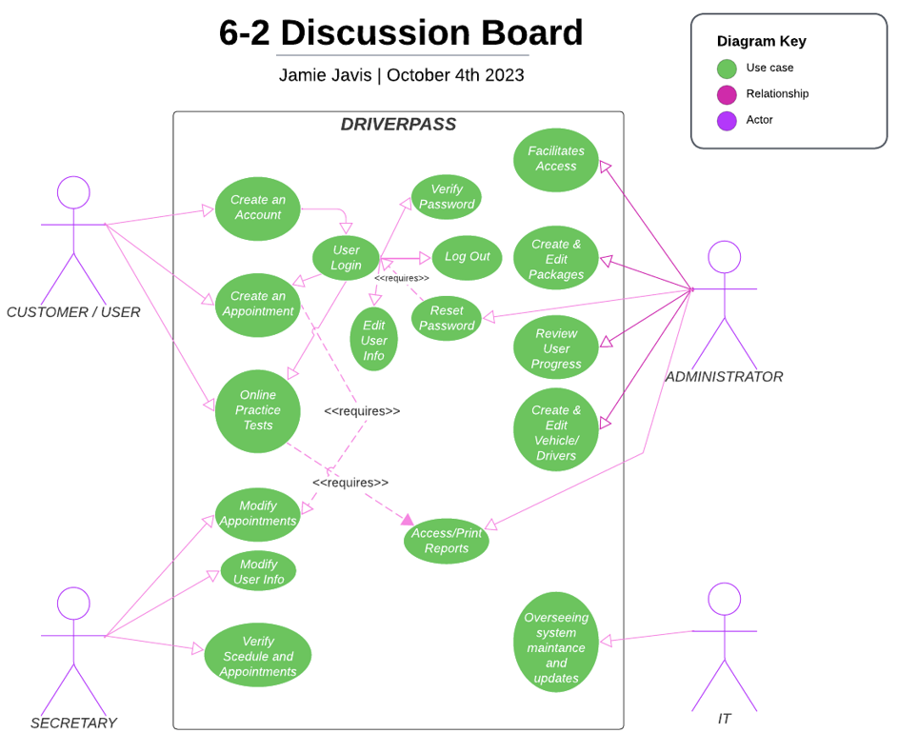

### UML Activity Diagrams

*

### UML Sequence Diagram

### UML Class Diagram

## Technical Requirements

The system will operate on all platforms requested. The system will be working with a cloud platform to achieve what DriverPass has requested. The system will run on the most updated versions of code to ensure that all security measures are met.